Project 1 Final Report
Wei-Yuan Su, Kehao Xu
https://github.com/Wayne0758/Computer-Vision
Milestone 1: Manual Feature Extraction and Matching
We began with manually identifying corresponding keypoints across three images (IMG_1223, IMG_1224, and IMG_1226). Each image pair had at least 10 point correspondences to enable robust homography and fundamental matrix estimation.

Homography Estimation:
- Computed using normalized DLT on manually selected points.
- Accuracy was validated by projecting unused test points and overlaying them on target images.
- Average RMS alignment error: ~2–3 pixels on planar regions.

Fundamental Matrix and Epipolar Geometry:
- Estimated using the normalized 8-point algorithm.
- Epipolar lines were visualized to validate F matrices, with close alignment.
- Cross-view consistency test showed a pixel error of 1.94, confirming internal geometric consistency.

Milestone 2: Automated Feature Extraction and Matching
Three automated detectors were evaluated: SIFT, SuperPoint, and DISK. For each, we performed:
- Automated feature extraction on IMG_1223, IMG_1224, IMG_1226 using SuperPoint, DISK, and SIFT.
- Homography and fundamental matrix estimation.
- Visualization of epipolar geometry before and after RANSAC.

Methods Comparison:
- Disk: Faster and more lightweight, but produced noisier matches.
- SIFT: More likely to find letters. More computationally expensive but very reliable for textured scenes.
- SuperPoint: More likely to find letters and edges. Balanced speed and robustness well, good for general purposes.

RANSAC effectively removed outliers, validating the robustness of automated pipelines and laying the groundwork for large-scale 3D reconstruction.

Milestone 3: 3D Reconstruction Using pycolmap
Using a dataset of 428 images of Kavli Hall, we conducted sparse 3D reconstruction with two matcher pipelines:
- SuperPoint + SuperGlue
- SIFT + NN-ratio
Table1: Results of SuperPoint+SuperGlue and SIFT+NN-ratio
Extractor+Matcher | SuperPoint+SuperGlue | SIFT+NN-ratio
num_reg_images | 104 | 211
num_points3D | 46742 | 23262
mean_track_length | 4.36 | 4.48
mean_observations_per_image | 1950.12 | 493.67
mean_reprojection_error | 1.46px | 1.33px

Observations:
- SuperPoint+SuperGlue produced denser, more complete reconstructions. Especially effective in textured and shaded areas (e.g., vines and awnings).
- SIFT+NN-ratio yielded fewer points, but with lower reprojection error, suggesting higher geometric precision.
- Some artifacts appeared in dense scenes with SuperPoint due to perspective ambiguity.

Bundle Adjustment:
- Optimized both camera poses and 3D point locations.
- Suppressed spurious points and enhanced model realism.

Dense 3D Point Cloud Generation:
Utilizing SuperPoint, we automatically detected robust keypoints across our multi-view image dataset with 107 images of the front door. SuperGlue further refined these matches through graph-based optimization, leading to an extraordinarily detailed and dense point cloud reconstruction. This method provided superior scene coverage and maintained high geometric precision, ensuring stability during bundle adjustment and refinement.
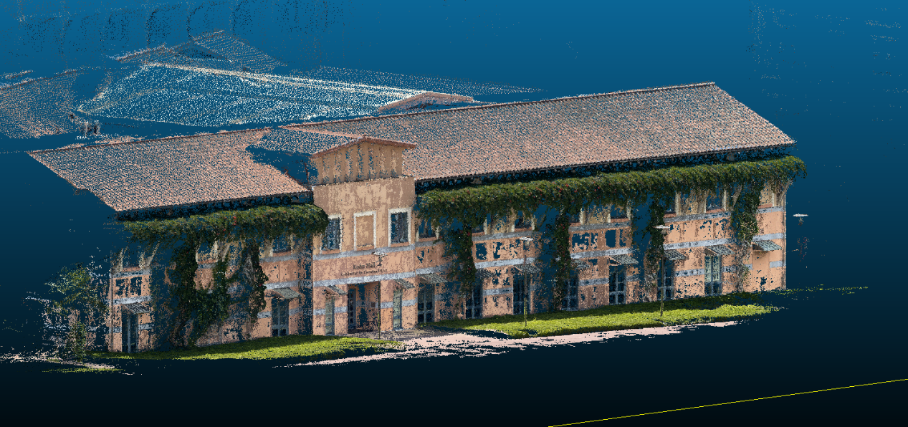

Milestone 4: Neural Radiance Fields or Gaussian Splatting for 3D Scene Generation
We reconstruct a highly detailed 3D model of Kavli Hall by leveraging state‐of‐the‐art deep feature matching and neural rendering techniques. We employed SuperPoint combined with SuperGlue to extract and match features across a dataset of images, resulting in an exceptionally dense 3D point cloud. Using this rich geometric foundation, we then applied Nerfstudio to generate a visually compelling and interactive 3D scene.

3D Scene Generation with Nerfstudio:
The dense point cloud served as the basis for our neural scene generation pipeline. Nerfstudio ingested the point cloud data and employed advanced Gaussian splatting techniques to render a photorealistic 3D scene of Kavli Hall. By optimizing parameters such as splat size, color blending, and transparency thresholds, we achieved a smooth transition from raw geometric data to a fully rendered scene that emphasizes fine details, depth, and lighting effects.
Picture 1
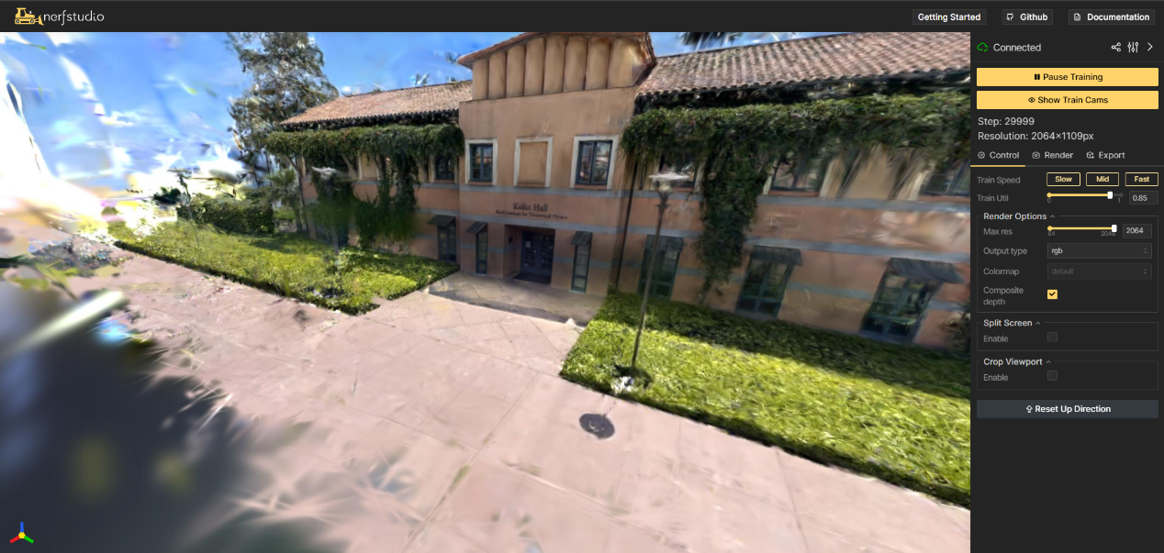

Challenges
- View Coverage: Some scene areas exhibited mild distortion due to incomplete multi-view coverage, especially near occlusions.
- Rendering Sensitivity: Minor changes in splat size or transparency had a large impact on rendering quality, requiring trial-and-error tuning.
- Hardware Limitations: High-resolution rendering pushed GPU memory usage to its limits, necessitating optimization of training speed and render resolution.

Conclusion:
Gaussian Splatting, especially through Nerfstudio, proved to be a powerful and efficient rendering method. Combined with dense geometric input from SuperPoint+SuperGlue, our final model effectively demonstrates the synergy between classical structure-from-motion and modern neural rendering.

Overall conclusion:
Throughout this project, we successfully implemented a comprehensive 3D reconstruction and rendering pipeline for Kavli Hall by progressing through four structured milestones. Beginning with manual feature matching, we gradually scaled up to automated methods and dense reconstruction using SuperPoint and SuperGlue, ultimately culminating in high-quality 3D scene rendering using Gaussian Splatting in Nerfstudio.

Each stage reinforced our understanding of multi-view geometry, epipolar constraints, feature detection, and neural rendering. The project demonstrated how classical computer vision techniques, when paired with modern neural approaches, can produce photo-realistic and geometrically consistent results. Despite challenges with rendering parameters, view coverage, and computational limits, the final outcome is a dense and immersive digital reconstruction of a real-world structure.

Looking forward, we recognize the potential of extending this pipeline to support real-time interaction, mesh extraction, and integration into AR/VR applications. This project serves as a strong foundation for future research and applications in photogrammetry, digital heritage, and autonomous systems.

